Power Pages 1 Day

Power Platform WorkshopPLUS

Lab 1: Power Pages Design Studio

Conditions and Terms of Use

Microsoft Confidential - For Internal Use Only

This training package is proprietary and confidential and is intended only for uses described in the training materials. Content and software is provided to you under a Non-Disclosure Agreement and cannot be distributed. Copying or disclosing all or any portion of the content and/or software included in such packages is strictly prohibited.

The contents of this package are for informational and training purposes only and are provided "as is" without warranty of any kind, whether express or implied, including but not limited to the implied warranties of merchantability, fitness for a particular purpose, and non-infringement.

Training package content, including URLs and other Internet Web site references, is subject to change without notice. Because Microsoft must respond to changing market conditions, the content should not be interpreted to be a commitment on the part of Microsoft, and Microsoft cannot guarantee the accuracy of any information presented after the date of publication. Unless otherwise noted, the companies, organizations, products, domain names, e-mail addresses, logos, people, places, and events depicted herein are fictitious, and no association with any real company, organization, product, domain name, e-mail address, logo, person, place, or event is intended or should be inferred.

© 2021 Microsoft Corporation. All rights reserved.

Copyright and Trademarks

© 2021 Microsoft Corporation. All rights reserved.

Microsoft may have patents, patent applications, trademarks, copyrights, or other intellectual property rights covering subject matter in this document. Except as expressly provided in written license agreement from Microsoft, the furnishing of this document does not give you any license to these patents, trademarks, copyrights, or other intellectual property.

Complying with all applicable copyright laws is the responsibility of the user. Without limiting the rights under copyright, no part of this document may be reproduced, stored in or introduced into a retrieval system, or transmitted in any form or by any means (electronic, mechanical, photocopying, recording, or otherwise), or for any purpose, without the express written permission of Microsoft Corporation.

For more information, see Use of Microsoft Copyrighted Content at

<http://www.microsoft.com/about/legal/permissions/>

Internet Explorer, Microsoft, Microsoft Dynamics, Microsoft Dynamics logo, and Windows are either registered trademarks or trademarks of Microsoft Corporation in the United States and/or other countries. Other Microsoft products mentioned herein may be either registered trademarks or trademarks of Microsoft Corporation in the United States and/or other countries. All other trademarks are property of their respective owners.

Table of Contents

Lab 1: Power Pages Design Studio 5

Part 1: Power Pages Design Studio Components 6

Part 2: Add a Web Page 12

Part 3: Portal Management 16

# Lab 1: Power Pages Design Studio

Introduction

This and the following labs will guide you through building Power Pages which will support the 311 system for a small town. This fictitious town is called Anytown 311, and they have a difficult time managing the following:

* Open employment positions
* Employment application
* Building Permits
* Public Safety Issues
* Repairs
* Etc.

Objectives

After completing this, you will be able to:

* Navigate in the Power Pages Design Studio
* Modify Pages components
* Add Web pages

Prerequisites

* Completed the Power Pages Set-up Guide

Estimated Time to Complete

* 20 minutes for the following steps

## Part 1: Power Pages Design Studio Components

1. Open a Private/Incognito browser session.
2. Navigate to [https://make.powerpages.microsoft.com/](https://make.powerapps.com/)
3. Log in using your credentials created during the lab set-up.
4. In the upper right corner, click on the default environment and switch to the Dataverse environment that you just created. Do not select the Default environment.

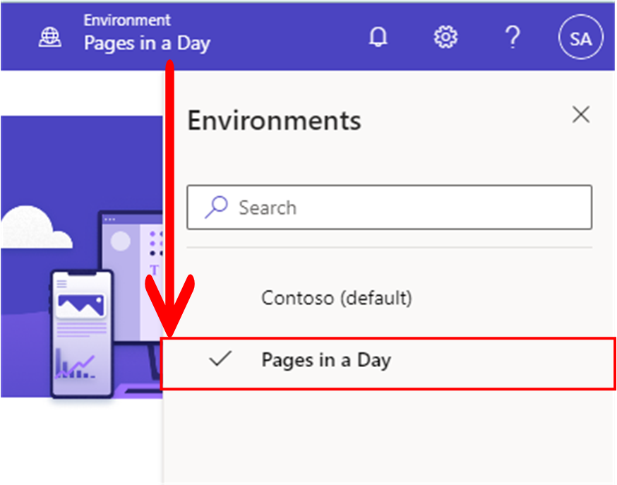

1. Select the **Edit** button on the Power Pages site created during the lab set-up via the **Home** tab.

1. On the left navigation bar, click the second icon down for **Styling**.
2. Scroll through **Themes** and choose one. You’ll need to click **Save** in the top right of the Styling pane after selecting a different theme.

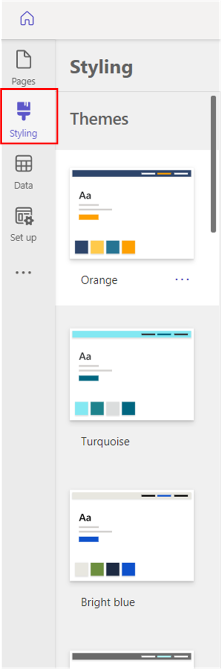

1. To the right of Themes, you will see **Color Palette**. This is how you can modify the preset colors of this theme. If you scroll down beneath Color Palette, you can also modify the **Background Color**, **Fonts**, **Buttons + Links**, and **Sections**.

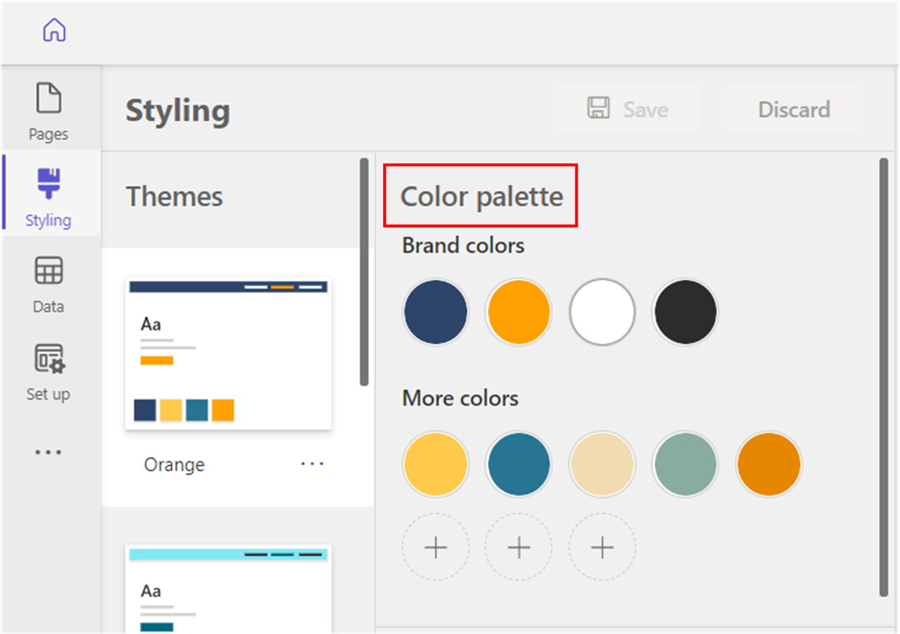

1. Next, navigate back to **Pages** via the left navigation bar. Change the default title of the site to something of your choosing by hovering over the header area and selecting **Edit site header**.

c

1. Close out of this pop-up window and change the homepage welcome message of the site to something of your choosing by selecting the text box in the body.

1. Scroll down to the **Featured Items** section that is approximately halfway down the home page.
2. Select the image above **Featured Item 1**.
   1. The image will be outlined. Select **Image** and the **Add an image** window will appear.

* 1. Within the editor you may:
     1. Select an existing image from the **Media library**
     2. Reference an external URL
     3. Upload a new image
        + Note: Supports .jpg, .jpeg, .bmp, .gif, .png formats with a maximum upload size of 5mb. Files uploaded here will be applied to all webpages and CSS will be available to public through website URL.
     4. Adjust the size by dragging the edges of the image.

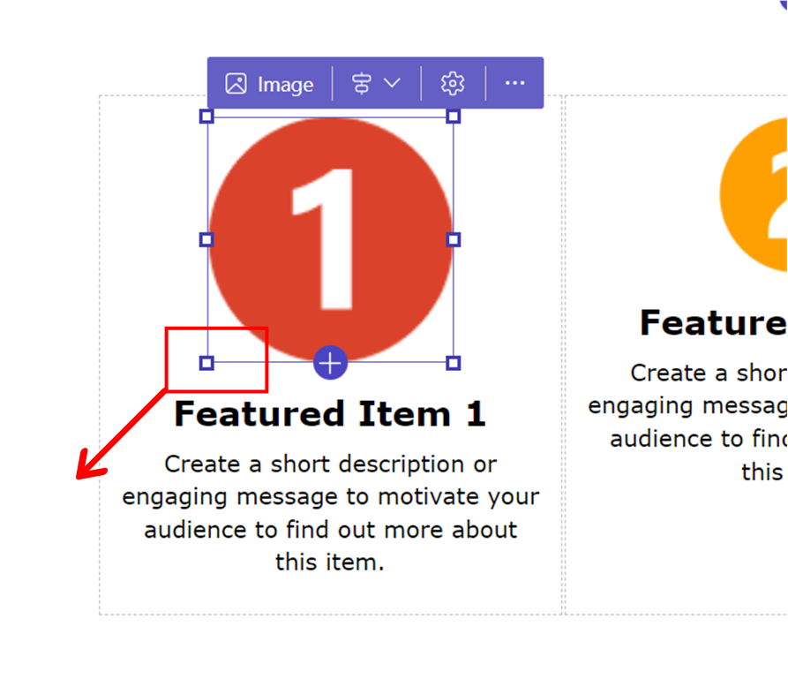

1. Locate an image on your machine or from an external location, upload it, and save your changes.
2. Select any component on the page, such as the image above. From the upper right, select **Edit code.**

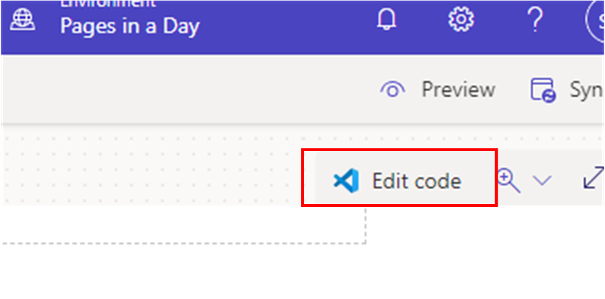

1. A pop-up window will appear. Click **Open Visual Studio Code**.



1. This will open a new tab with Visual Studio Code online. This allows one to review the source code or apply and save manual changes.
2. Navigate back to the Design Studio tab.

## Part 2: Add a Web Page

1. In the **Pages** tab, click **+ Page** > **Standard Layouts > Page**
2. Set the page name as **FAQ** and click **Add.**
   1. This window will close, and a new web page will be created.

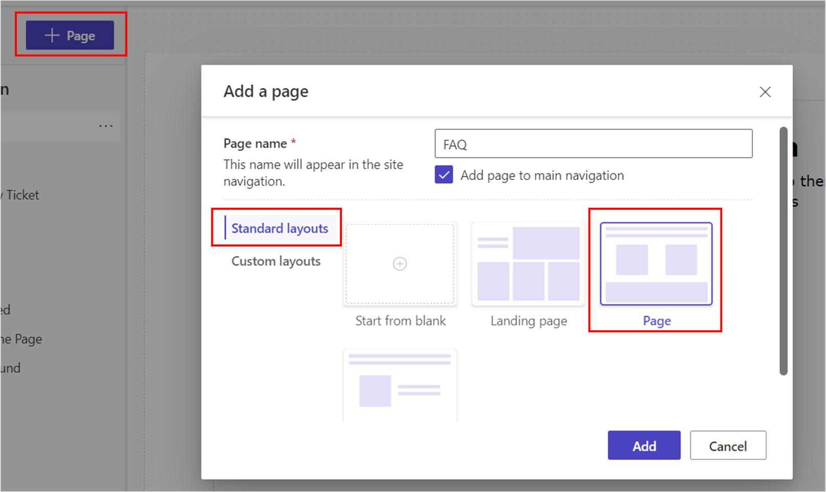

1. Hover over your newly created **FAQ** page within the list of pages and click on the ellipses (**…**) that appears to the right of the page name.
2. Click on **Page settings.**

1. Note the **Name** and **Partial URL**. You can modify both of these fields.
2. Close out of this pop-up window if you do not make any changes. If you’ve made changes to any of these fields, click **OK**.

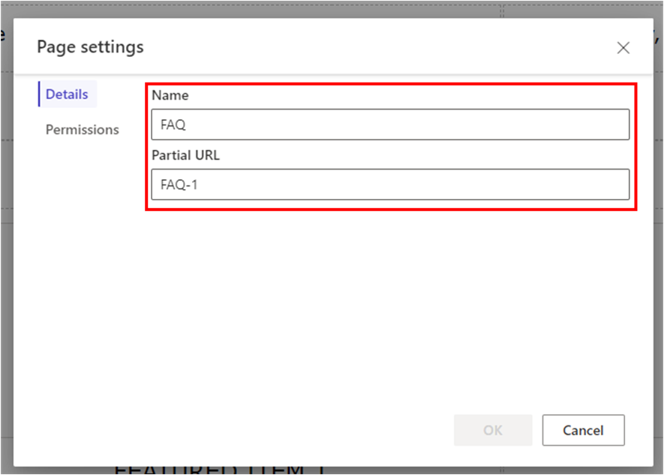

1. Hover your mouse over the dotted lines between the first and second sections. A circular button with a “**+**” will appear. Click on this button.
2. Section layout options will appear. Select **2 Column**.

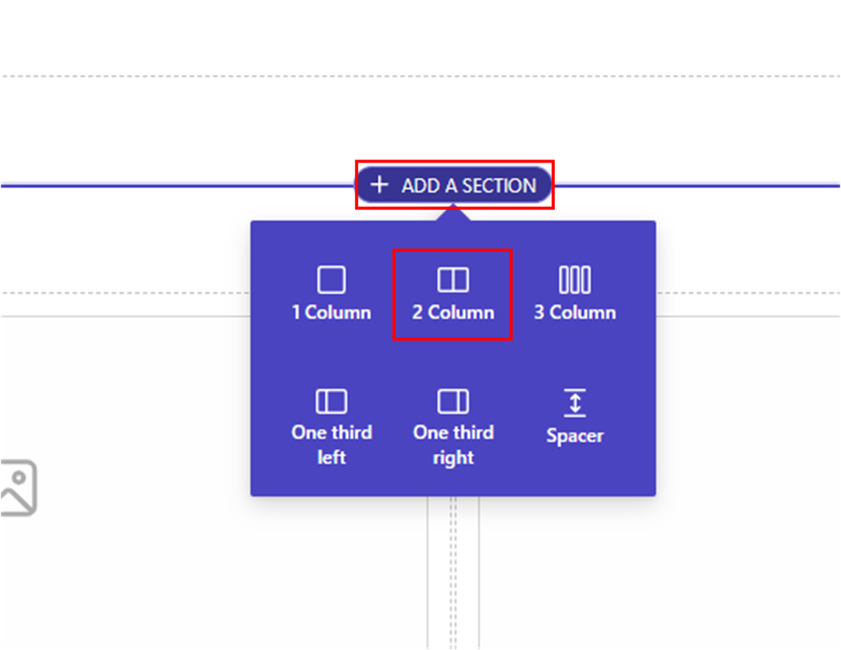

1. On the left column, choose the first icon for the **Text** component. Repeat this for the right column.

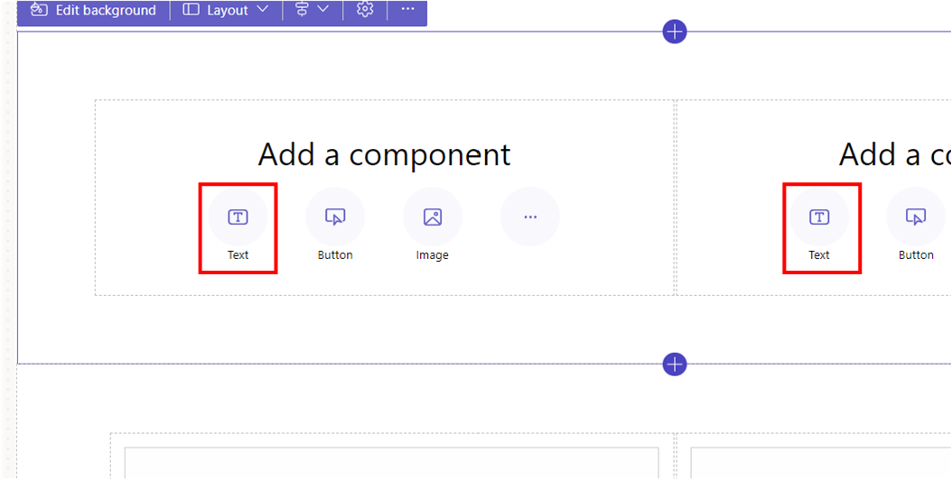

1. Populate one column with FAQ's, the other column with Answers.
   1. Add three to four questions in the left column with corresponding answers in the right column.
   2. To add additional text lines within the same section, click on the circular button with the “**+**” symbol beneath the original text box and select **Text** from the component options.

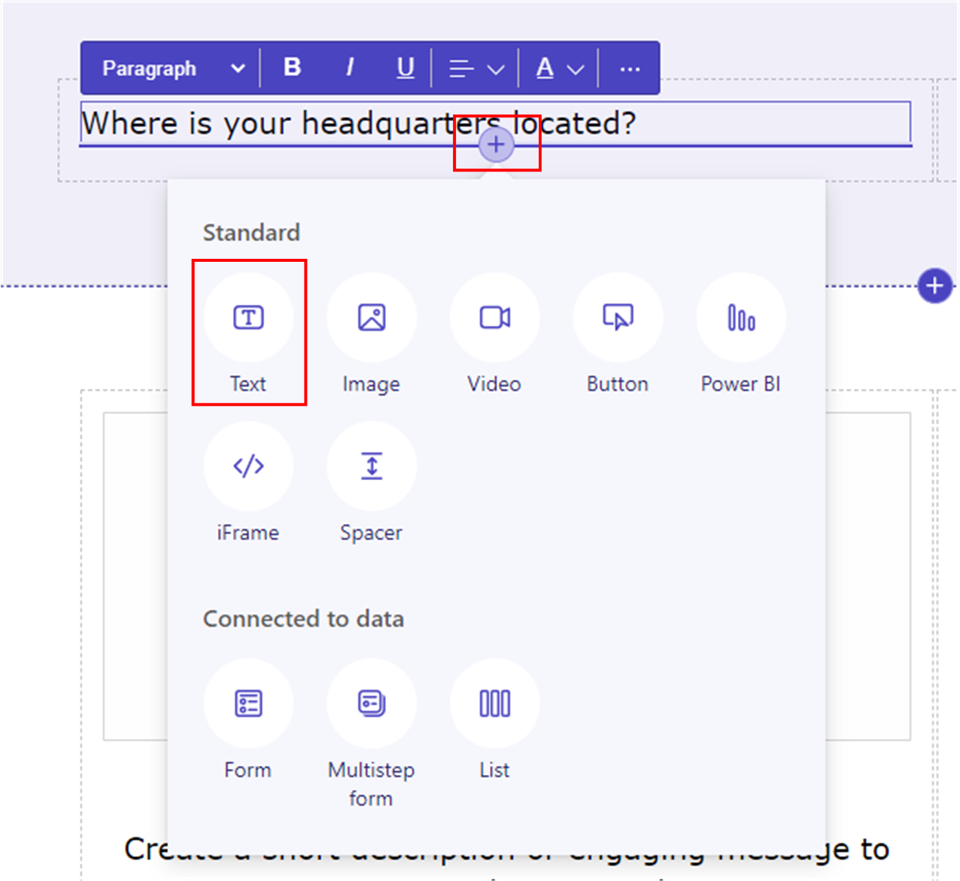

1. When you are ready to preview this in your browser, click **Sync** in the top right corner, then select **Preview > Desktop**.

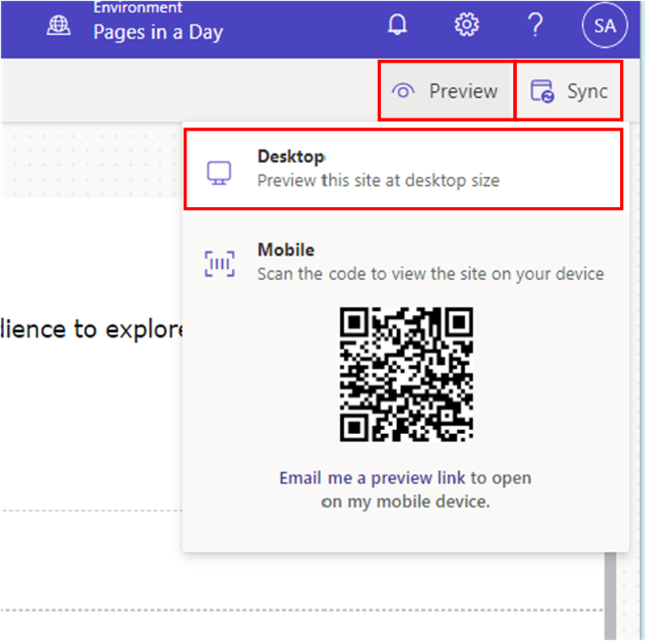

1. Explore the site and observe the changes you have made.

## Part 3: Portal Management

1. From the left navigation bar, select the ellipses (**…**) and then select **Portal Management.** 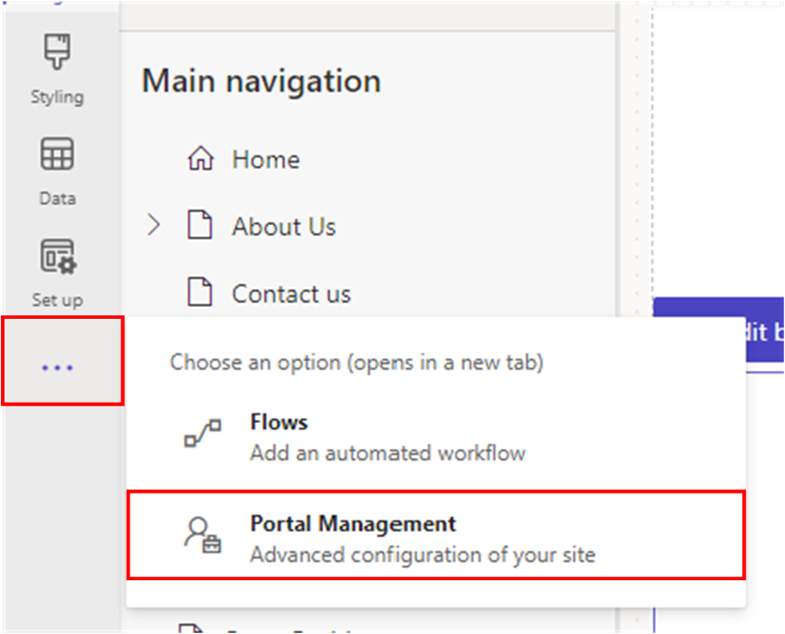
2. From the left-hand navigation, locate **Web Pages** and select it.
3. Note that a configuration record in Dataverse has been created for the FAQ web page you created in the Power Pages Design Studio.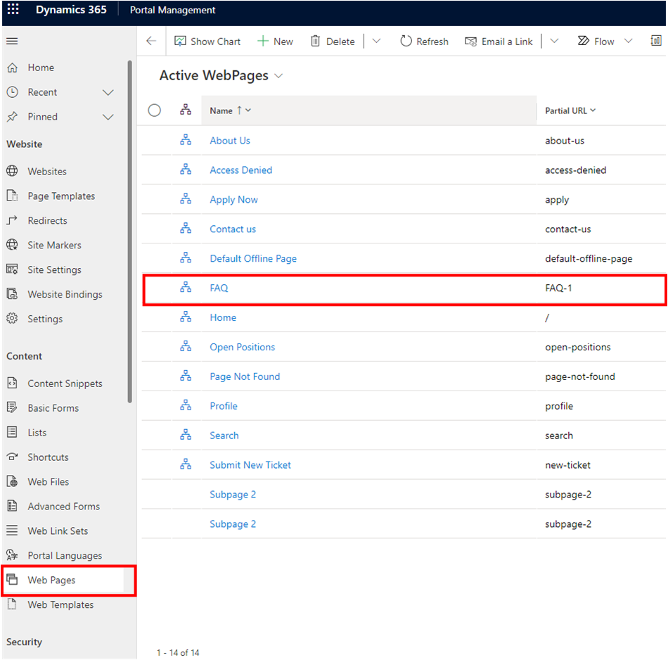

You have completed Lab 1.